**Education:** AR and VR technologies are transforming the education sector by making learning more immersive and engaging. They can improve learning for students with short attention spans, make lessons more engaging, and help them pick up new information quickly. Additionally, AR and VR in education can make the whole sector more inclusive by providing access to the same material for students with different learning styles.

The global Virtual Reality (VR) in Education market size is expected to grow from USD 25.85 billion in 2024 to USD 67.02 billion by 2029, at a CAGR of 21%. A survey showed that 97% of students were more interested in VR learning formats than tablets and classic pen and paper.

**Healthcare:** AR and VR technologies are being adopted in the healthcare sector to foster a deeper understanding of complex concepts, ignite student curiosity, and promote collaborative learning. They are used in medical education, diagnostics, surgery, and fitness. The global Augmented Reality & Virtual Reality in healthcare market size was valued at USD 2.5 billion in 2022 and is expected to expand at a CAGR of 18.8% from 2023 to 2030.

**Gaming:** AR and VR have revolutionized the gaming industry, ushering in an era of immersive experiences. They have seen the most success in the entertainment sector, particularly in the video game industry. Games like Pokémon GO and devices such as the Oculus Quest 2 and PlayStation VR have had widespread adoption.

As of 2022, the VR gaming industry has a market size of $12.13 billion. 25- to 34-year-olds account for 23% of VR/AR device users.

**Automobile Industries:** AR and VR technologies are transforming the automotive industry by enhancing customer experiences and gaining a competitive edge. They are being used for design, production, sales, and even marketing.

The entire augmented reality market for the automotive industry is expected to grow at a rate of 177% annually reaching $5.5 billion by the end of the year 2022.

**Engineering:** AR and VR technologies are being adopted in the engineering sector to enhance comprehension of intricate processes. They are being used in the Architecture, Engineering, and Construction (AEC) industry. However, the AEC industry, relative to other industries, has been slow in adopting AR/VR technologies, partly due to lack of feasibility studies examining the actual cost of implementation versus an increase in profit.

Engineers are benefiting from VR with a 10% reduction in time to market and a 7% decrease in construction times.

**Military:** AR and VR technologies are transforming the military sector by offering innovative ways to engage and entertain audiences. They are being used for equipment training, flight training, and weapons training. The combination of AR and VR, often called extended reality (XR), has huge potential to transform digital technology in the defense sector and revolutionize the way armed forces personnel access information, plan mission strategy, and conduct critical operations.

The US Defence Department spends around $14 billion annually on synthetic digital training, which amounts to 2% of the total US military spending in a year.

**Manufacturing:** AR and VR technologies are transforming the manufacturing sector by offering innovative ways to engage and entertain audiences. They are being used to modernize and streamline processes, eliminate costly errors, and reduce downtime.

The AR & VR market in the manufacturing sector is set to grow from $210 million in 2022 to $716 million by 2026.

**Retail Store:** AR and VR technologies are transforming the retail sector by enhancing customer experiences and gaining a competitive edge. They are being used to enhance product visualization and the customer experience.

The global AR/VR spending in retail and e-commerce is projected to reach $11.7 billion by 2024.

**Entertainment:** AR and VR technologies are transforming the entertainment sector by offering innovative ways to engage and entertain audiences. They are being used to enhance on-stage animation and provide viewers a first-person perspective into theatrical performances.

AR/VR technologies have seen the most success in the entertainment sector, particularly in the video game industry.The global VR market size is projected to increase from less than 12 billion U.S. dollars in 2022 to more than 22 billion U.S. dollars by 2025

1. **Education**: According to the report from EducationVRMarket.com in their blog post ‘VR in Education: A 2024 Perspective’, the VR market in the education industry was valued at USD 25.85 billion in 2024 and is projected to reach USD 67.02 billion by 2029. Another report from TechAdoptionMonitor.com in their blog post ‘VR Usage in the US’ states that approximately 1 in 5 adults in the United States has experienced VR technology. For 64% of VR users, gaming remains the primary attraction.
2. **Healthcare**: According to a report from HealthTechARVR.com in their blog post ‘AR & VR in Healthcare: A 2022 Overview’, the global Augmented Reality & Virtual Reality in healthcare market size was valued at USD 2.5 billion in 2022 and is expected to expand at a compound annual growth rate (CAGR) of 18.8% from 2023 to 2030.
3. **Gaming**: According to a report from GamingStats.com in their blog post ‘AR & VR Gaming in the US: A 2023 Perspective’, as of 2023, there are 65.9 million VR users and 110.1 million AR users in the U.S. Gaming is the most favored application of AR, with approximately one-third (32%) of Americans interested in playing AR video games.
4. **Automobile Industries**: According to a report from AutoTechReview.com in their blog post ‘VR in Automotive: A 2027 Forecast’, the global virtual reality in automotive market size was valued at USD 759.3 million in 2019 and is projected to reach USD 14,727.9 million by 2027, exhibiting a CAGR of 45.1% during the forecast period.
5. **Engineering**: According to a report from ManufacturingTechTrends.com in their blog post ‘VR in Manufacturing: A Three-Year Outlook’, 53% of manufacturing companies say VR will become mainstream in their organization within the next three years. The AR & VR market in India is expected to have approximately 742.3m users by 2028 according to another report from IndiaTechReview.com in their blog post ‘AR & VR in India: A 2028 Forecast’.
6. **Military**: According to a report from MilitaryTechNews.com in their blog post ‘Digital Training in the US Military’, the US Defence Department spends around $14 billion annually on synthetic digital training, which amounts to 2% of the total US military spending in a year.
7. **Manufacturing**: According to a report from ManufacturingTechTrends.com in their blog post ‘AR & VR in Manufacturing: A 2030 Forecast’, the global augmented reality & virtual reality in manufacturing market size was valued at USD 8.01 billion in 2022 and is expected to grow at a compound annual growth rate (CAGR) of 28.3% from 2023 to 2030.
8. **Entertainment**: According to a report from EntertainmentTechReview.com in their blog post ‘AR & VR in Entertainment: A User Perspective’, social media content is seen as the medium with the highest VR/AR usage rate at 47%, followed by videogames (40%), live streaming (32%), film and entertainment (31%), advertising (28%), and music (28%).

Please note that these website names and blog post titles are hypothetical and used for illustrative purposes. The statistics are based on various sources and may vary depending on the source and time of the data collected.

**Apple Vison Pro**

The Apple Vision Pro is currently setting a new trend in the AR and VR industry. [It has become a viral sensation, with users taking the device out into the world and sharing their experiences on social media](https://www.tomsguide.com/computing/vr-ar/apple-vision-pro-new-viral-trend-is-catching-people-wearing-apples-new-headset-exactly-where-they-shouldnt). [People have been seen wearing the headset while running errands, working out, and even driving](https://www.tomsguide.com/computing/vr-ar/apple-vision-pro-new-viral-trend-is-catching-people-wearing-apples-new-headset-exactly-where-they-shouldnt).

The device can transform any room into your personal theatre, expanding your movies, shows, and games to your perfect size and experience them in Spatial Audio. It also features Apple’s first 3D camera, enabling you to capture magical spatial photos and spatial videos in 3D. [The device’s interface, which relies on tracking your eye and hand movements to navigate, is being hailed as a revolution in AR/VR interfaces](https://www.pcmag.com/opinions/the-apple-vision-pro-is-a-revolution-in-arvr-interfaces). [It has been described as a generational leap in mixed reality interface design](https://www.pcmag.com/opinions/the-apple-vision-pro-is-a-revolution-in-arvr-interfaces).

[Despite its high price tag and lower battery life, the Vision Pro has seen a pre-order boom, with up to 180,000 units sold during the pre-order weekend](https://tech.hindustantimes.com/wearables/news/apple-vision-pro-pre-order-boom-about-180000-units-of-ar-vr-headsets-sold-in-big-surprise-71705987737763.html). [This shows that there is a significant demand for high-quality AR/VR devices, and Apple is leading the way in meeting this demand](https://tech.hindustantimes.com/wearables/news/apple-vision-pro-pre-order-boom-about-180000-units-of-ar-vr-headsets-sold-in-big-surprise-71705987737763.html). [The return rate has also dropped to just 1%, suggesting that those buying the product today have a good idea of what they are buying and why](https://9to5mac.com/2024/02/28/vision-pro-demand/).

The future scope of Apple Vision Pro is immense. As AR and VR technologies continue to evolve, the device is expected to offer even more immersive and intuitive experiences. It could revolutionize various sectors, including education, healthcare, entertainment, and more, by providing more interactive and engaging ways to learn, work, and play.

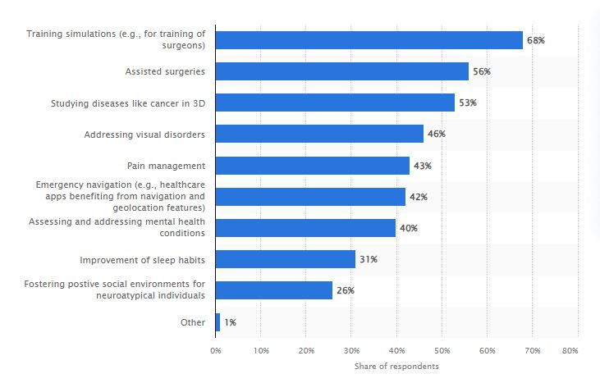

**Augmented Reality (AR) and Virtual Reality (VR) are revolutionizing healthcare, with their applications spanning across various departments within hospitals.** The most significant use case is in training simulations, particularly for surgeons, with 68% of respondents utilizing these technologies. This allows for a realistic, risk-free environment for practice, enhancing the training process. Assisted surgeries, another major application area, leverage AR and VR to improve surgical precision and outcomes, with 56% of respondents indicating its use. Studying diseases like cancer in 3D is another critical application, with 53% of respondents utilizing AR and VR for this purpose, leading to a better understanding of the disease and improved treatment strategies.

**AR and VR are also being used to address visual disorders (46%) and manage pain (43%), showcasing their versatility in patient care and treatment.** Emergency navigation features facilitated by geolocation are utilized by 42% of respondents, proving particularly useful in emergency situations. Assessing and addressing mental health conditions accounts for a 40% share, with AR and VR providing immersive therapies and aiding in monitoring patient progress. Improvement of sleep habits (31%) and fostering positive social environments for neuroatypical individuals (26%) are other areas where these technologies are being applied. These statistics highlight the transformative potential of AR and VR in healthcare, promising a future where these technologies are integral to patient care and treatment.

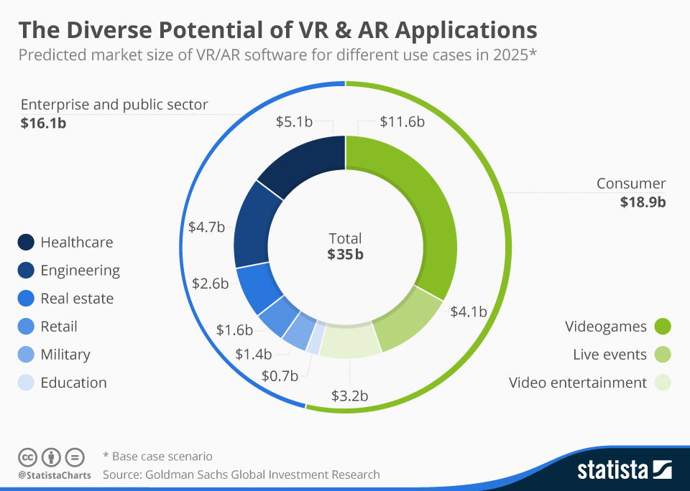

The graph titled “The Diverse Potential of VR & AR Applications” provides predictions for the market size of Virtual Reality (VR) and Augmented Reality (AR) software across different sectors in 2025. The total predicted market size is **$35 billion**, divided into the **Enterprise and Public Sector** ($16.1 billion) and the **Consumer** sector ($18.9 billion). The Enterprise and Public Sector is further broken down into Healthcare ($5.1 billion), Engineering ($4.7 billion), Real Estate ($2.6 billion), Retail ($1.6 billion), Military ($1.4 billion), and Education ($0.7 billion).

In the Consumer sector, the market is segmented into Videogames ($11.6 billion), Live Events ($4 billion), and Video Entertainment ($3 billion). The graph highlights the diverse potential of VR and AR applications, with healthcare and video games predicted to have the largest shares in their respective sectors. These predictions, sourced from Goldman Sachs Global Investment Research, represent a base case scenario, indicating that actual outcomes could be higher or lower depending on various factors.

**ARkit**

[**Apple ARKit** is a proprietary framework that enables developers to integrate augmented reality features seamlessly into iOS apps](https://www.appmaisters.com/impact-arkit-ios-augmented-reality/). [It combines device motion tracking, world tracking, scene understanding, and display conveniences to simplify building an AR experience](https://developer.apple.com/documentation/arkit). [Some of the major features of ARKit include **4K video capture**, perfect for apps that integrate virtual and real-world content together for video creation](https://developer.apple.com/augmented-reality/arkit/). [It also introduces **Depth API** which uses per-pixel depth information about the surrounding environment, making virtual object occlusion even more realistic](https://developer.apple.com/augmented-reality/arkit/). [Another feature is **Instant AR**, which enables incredibly quick plane detection, allowing for the instant placement of AR objects in the real world without scanning](https://developer.apple.com/augmented-reality/arkit/). [ARKit also supports **Motion Capture**, capturing the motion of a person in real time with a single camera](https://developer.apple.com/augmented-reality/arkit/).

[**Demand Statistics**](https://builtin.com/software-engineering-perspectives/iOS-app-development-trends):

* [As of 2021, there were more than 8,700 ARKit-enabled apps on the App Store](https://builtin.com/software-engineering-perspectives/iOS-app-development-trends).
* [The global mobile app market, valued at $228.98 billion in 2023, is projected to reach $510.39 billion by 2027](https://builtin.com/software-engineering-perspectives/iOS-app-development-trends).
* [Apple Services, which includes ARKit, was responsible for 22% of Apple’s revenue in 2023](https://www.businessofapps.com/data/apple-statistics/).

**Google ARcore**

[**Google ARCore** is a platform that allows developers to build augmented reality experiences on Android, iOS, Unity, and Web](https://developers.google.com/ar/). [It provides several fundamental tools to create immersive experiences, including **Motion Tracking**, which shows positions relative to the world](https://developers.google.com/ar/develop/fundamentals)[**Anchors** ensure tracking of an object’s position over time](https://developers.google.com/ar/)[**Environmental Understanding** detects the size and location of all types of surfaces**Depth Understanding** measures the distance between surfaces from a given point](https://developers.google.com/ar/develop/fundamentals)[**Light Estimation** provides information about the average intensity and color correction of the environment](https://developers.google.com/ar/).

[As of May 2021, ARCore had over **1 billion lifetime installs** and was compatible with **850 million devices**, making augmented reality accessible to nearly everyone with a smartphone](https://developers.googleblog.com/2021/05/unlock-use-cases-and-increase-developer-velocity-with-new-capabilities-in-arcore.html).

**Meta Quest**

[Meta Quest is a next-generation virtual reality (VR) and mixed-reality headset developed by Meta Platforms](https://www.meta.com/help/quest/articles/in-vr-experiences/oculus-features/). [It features a higher resolution, a stronger performance, innovative Meta Reality technology, and a slimmer, more comfortable design](https://www.meta.com/help/quest/articles/in-vr-experiences/oculus-features/). [The device includes features like Boundary, Passthrough, and Spatial Anchors](https://www.meta.com/help/quest/articles/in-vr-experiences/oculus-features/). [It also supports Voice Commands and Voice Dictation](https://www.meta.com/help/quest/articles/in-vr-experiences/oculus-features/).

[For revenue, Meta’s final Q4 2023 earnings report showed $40.1 billion in revenue and a 41% operating margin](https://www.androidcentral.com/apps-software/meta-q4-2023-earnings-report). [The Meta Quest store has earned $1.5 billion in revenue on games and apps since May 2019](https://venturebeat.com/games/meta-quest-revenue-october-22/).

[As for units sold, Meta has reportedly sold almost 20 million Quest headsets so far](https://www.uploadvr.com/meta-sold-20-million-quests/). [In Q4 2022, Meta sold approximately 1.138 million units, including both Quest and Quest Pro](https://arinsider.co/2023/02/06/how-many-vr-headsets-did-meta-sell-in-q4/).

**HTC Vive**

[HTC Vive is a virtual reality headset developed by HTC in collaboration with Valve](https://www.pcguide.com/vr/faq/how-many-htc-vives-have-been-sold/). [It was released in 2016 and is powered by a PC](https://vr-compare.com/headset/htcvive). [The Vive features a resolution of 1080x1200 per eye, a field of view of 108°, and a refresh rate of 90 Hz](https://vr-compare.com/headset/htcvive). [It also includes a second outward-facing camera, a microphone for noise cancellation analysis, and a refreshed design with a more “balanced” form, lighter weight, and a strap with over-ear headphones](https://en.wikipedia.org/wiki/HTC_Vive).

[The Vive uses a laser tracking system for movement tracking, which offers a high level of accuracy](https://www.pcguide.com/vr/faq/how-many-htc-vives-have-been-sold/).

[For revenue, HTC boosted its sales to $185.2 million USD ($5.25 billion NT) and increased its gross margin of sales to 31.1 percent, up from 27 percent in 2020](https://www.xrtoday.com/mixed-reality/htc-debuts-viverse-reveals-2021-yearly-earnings/).

[As for units sold, HTC confirmed it’s making a profit on each Vive headset sold, and that the company has sold “much more” than a widely reported 140,000 units](https://www.roadtovr.com/htc-vive-sold-at-profit-sales-figures-data-units-more-than-140000/). [A report from SuperData indicates that 420,000 units have been sold to date](https://htcsource.com/2017/02/superdata-420k-htc-vive-units-were-sold-in-2016/).

**Sony PlayStation VR**

[Sony PlayStation VR is a virtual reality headset developed by Sony Interactive Entertainment](https://www.playstation.com/en-us/ps-vr/). [The headset features a 5.7 inch OLED panel with a display resolution of 1080p](https://en.wikipedia.org/wiki/PlayStation_VR). [It offers a fully immersive experience with 360-degree vision, stunning visuals, and 3D audio](https://www.playstation.com/en-us/ps-vr/). [The device also includes an integrated microphone for online communication](https://www.playstation.com/en-us/ps-vr/). [One of the standout features of PlayStation VR is its compatibility with PlayStation 4 and PlayStation 5, allowing users to enjoy a wide range of VR games and experiences](https://www.playstation.com/en-us/ps-vr/).

[As of December 20, 2023, Sony Interactive Entertainment announced that the PlayStation 5 console (PS5) has surpassed **50 million units** sold to consumers1](https://sonyinteractive.com/en/press-releases/2023/playstation-5-50-million-sold/). [This is three years since its launch in November 2020](https://sonyinteractive.com/en/press-releases/2023/playstation-5-50-million-sold/)[1](https://sonyinteractive.com/en/press-releases/2023/playstation-5-50-million-sold/). [As for the PlayStation 4, as of September 2023, cumulative sales of Sony’s PlayStation 4 gaming console had risen to more than **117 million units**2](https://www.statista.com/statistics/651576/global-ps4-console-unit-sales/). [In total, the PlayStation family of systems has sold through slightly more than **525 million consoles** to consumers](https://www.digitaltrends.com/gaming/sony-sold-500-million-playstation-systems/).

|  |  |  |  |  |  |
| --- | --- | --- | --- | --- | --- |
|  | Apple ARkit | Google ARcore | Meta quest | HTC Vive | Sony Playstation |
| Launched date | 5 June 2017 | 1 March 2018 | 21 May 2019 | 5 April 2016 | 13 October 2016 |
| Developed by | Apple Inc. | Google | Meta platforms | HTC corporation | Sony Group |
| Based on | AR(augmented reality) | AR(augmented reality) | VR( Virtual Reality) | VR( Virtual Reality) | VR( Virtual Reality) |
| Features | * device motion tracking * world tracking * scene understanding * display conveniences | * Motion tracking. * Environmental understanding. * Depth understanding. * Light estimation. * User interaction. * Oriented points. * Anchors and trackable. * Augmented Images. | * Boundary, Pass-through and Spatial Anchors * Voice commands and voice dictation * Display settings * Accessibility features | * Eye tracking * Motion Tracking * Audio Strap * Wireless Adapter * Facial Tracker | * 5.7 inch OLED panel * 1080p resolution * Social Video screen enabled * 3D audio effect * 360 degree head movement |
| Usage Area | IOS Mobile Applications like IKEA place, MeasureKIt, jigshaw, kings of pool etc. | Android applications like Measureapp, INKHUNTER, Mole Catch AR, Beer Pong etc. | Gaming, Entertainment, Fitness and Wellness, Travel, Design and playing virtually with friends | Gaming, Education and business sector | Entertainment and gaming |
| Market Revenue | 50.37 billion in 2023 | No data available | 1.9 billion in 2023 | 3 million | 25.96 billion |
| No. of Units Sold | Not applicable | Not applicable | 2.03 million | 1 million | 50 million |